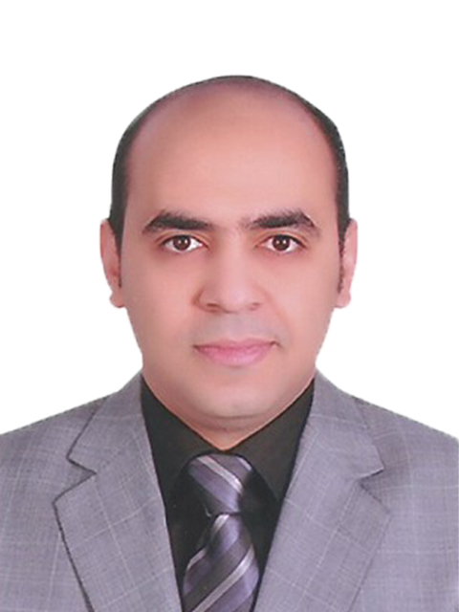
Dr. Mahmoud Abdel-Radi
Education &Academic positions
* Graduated from Faculty of Medicine Assiut University in Sep.2004.
* House officer from Mar 2005 until Feb 2006 in Assiut University.
* Residency at ophthalmology department – Assiut University
Hospitals in Mar 2006 & finished in Feb 2009.
* Demonstrator of ophthalmology - Ophthalmology department –
Faculty of Medicine / Assiut university since March 2009 .
* Assistant lecturer of ophthalmology - Ophthalmology department –
Faculty of Medicine / Assiut university since July 2009 .
* Lecturer of ophthalmology - Ophthalmology department – Faculty of
Medicine / Assiut university since December 2013 .
* Associate Professor of ophthalmology - Ophthalmology department –
Faculty of Medicine / Assiut university since July 2020.
Qualifications
MB ChB -Assiut university - September 2004
Master degree in ophthalmology -Assiut university - April 2009
Doctorate degree (MD) in ophthalmology -Assiut university-
November 2013
ORCID iD: 0000-0002-9383-9520
Google Scholar: https://scholar.google.com/citations?user=R7JMp2sAAAAJ&hl=en

